Main Screen

1. In the header division, in the right corner, three icons [1. fb 2. Instagram 3. twitter] added.

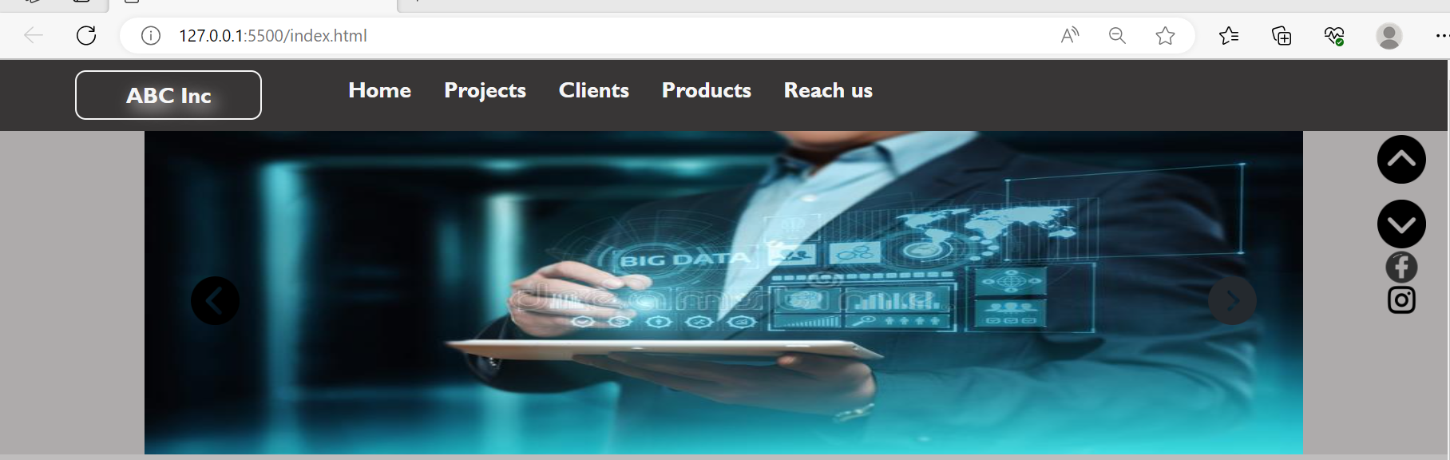

If I click the fb icon then My account is opend

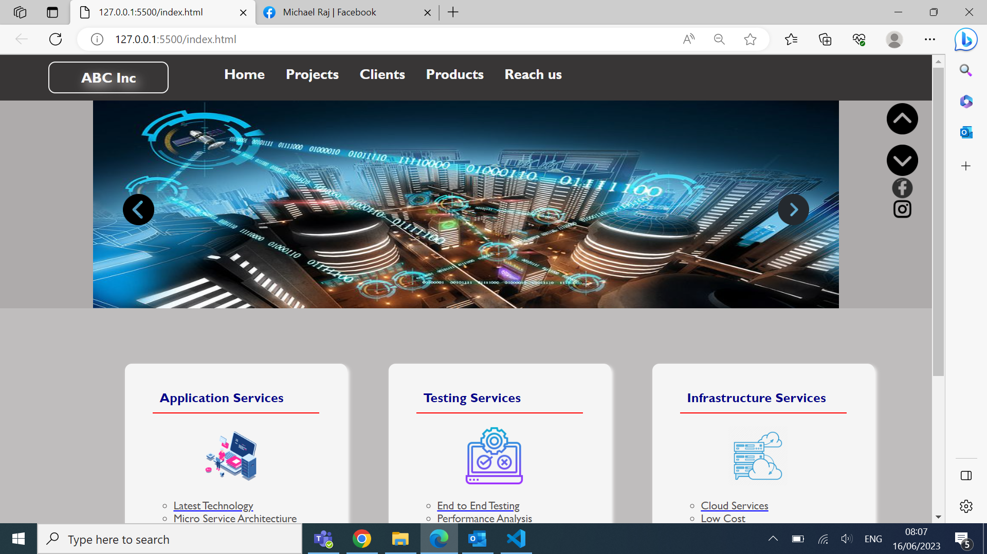

If I click the insta icon then My account is opend

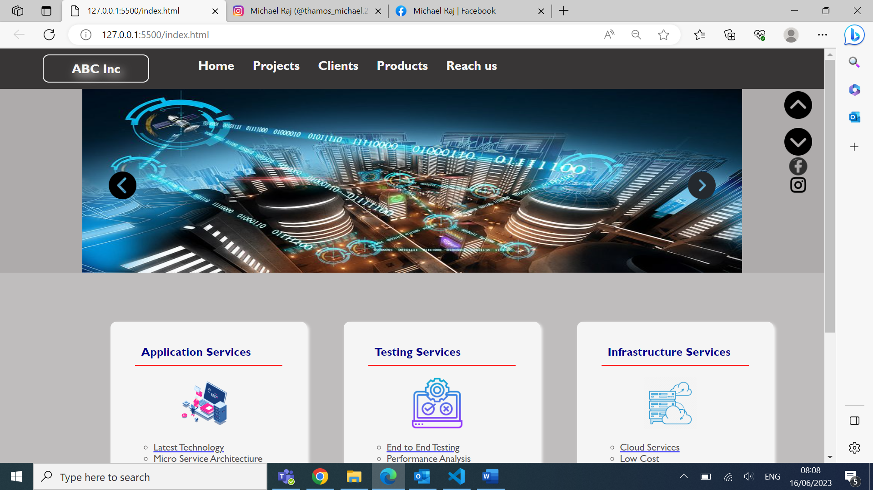

1. In the service-box division, the features list item is showing clickable cursor/pointer and if clicked, then called a function and the function is alerting the content of current li.

1. In the service-box image if take mouse over it the image moving right side by 50px and when take away mouse pointer it is going back to original positioning.



1. After clicking the up-arrow button in right side, the slide-area is hidden in the below screen and down-arrow button shown.

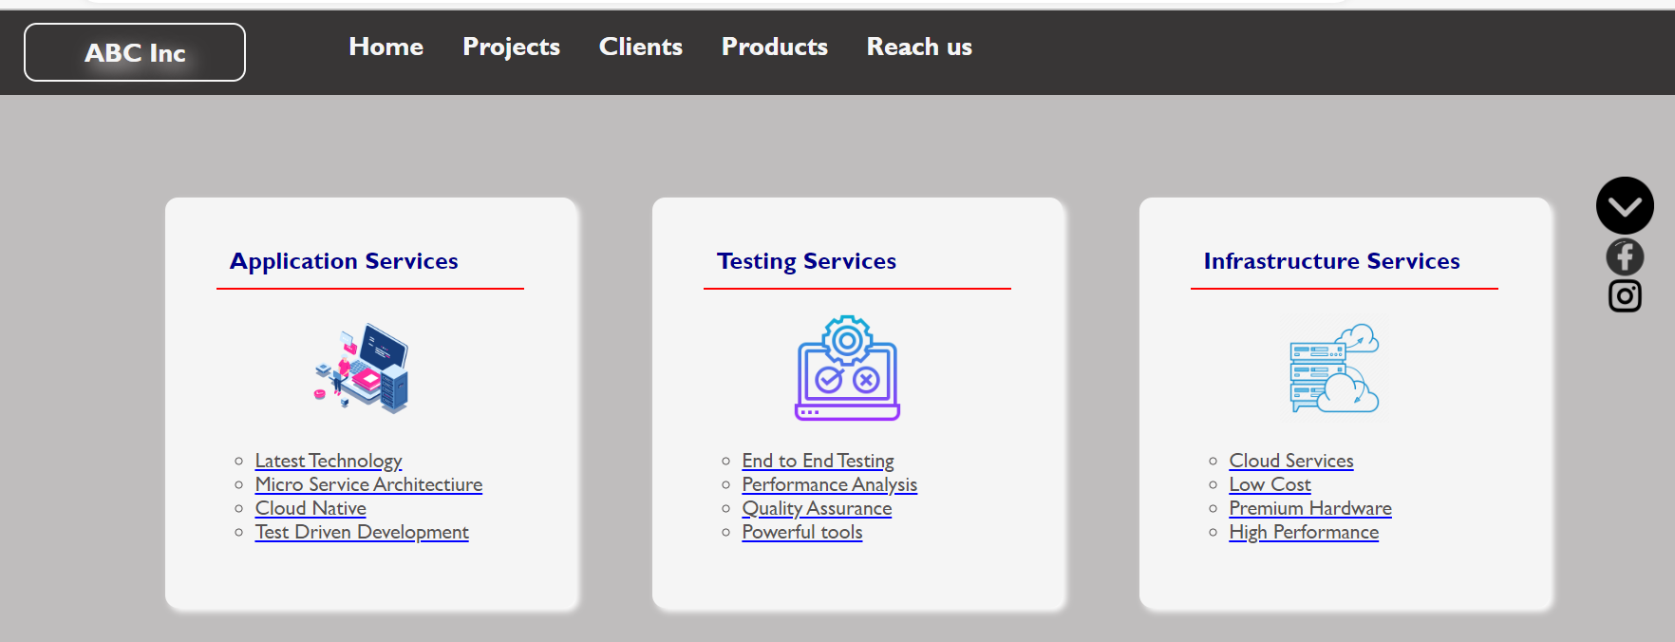

1. After clicking the down-arrow button in right side, the slide-area is shown again in the below screen and up-arrow button shown.

